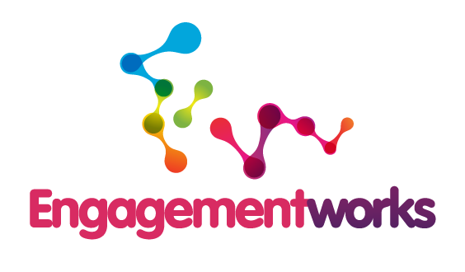

Community Engagement
Planning Templates

©Engagementworks Limited 2014

Template 1
Clarifying and defining your overall project objectives

Outline your project objectives
What are the overall goals for the project?
What are the major assumptions and requirements for the project (refer to your Evaluation Plan for your project if developed)?
What are the specific deliverables for your project?
What are the key responsibilities of the project and how do these relate to the Community Engagement Plan?
What decisions have already been made that will affect the development of the Community Engagement Planning process?
What aspects of this situation are negotiable or not negotiable? (e.g. legislation, policy, etc.)
Template 2
Your Mind Map

When you have completed your Mind Map use an * to identify the citizens and stakeholders who are:
- Crucial to implementing your project objective and
- Who will make or implement the intended outcomes or take action in the process

Describe the economic, environmental, social and cultural conditions of your project

Template 3
Deﬁning Citizens and Stakeholders

List citizens or stakeholders  (revisit your mind map and ensure you include those you noted with an *) | What are their values and needs?
1.

2.

3.

4.

5.

6.

7.

8.

9.

10.

11.

12.

13.

14.

15.

Template 4
Citizens and stakeholder relationship to the project

1. Citizen and  Stakeholder Groups  (Translate this information from Template 3 to here and column 1 from Template 6 – Your Community Engagement Plan. | 2.Needs at stake in relation to project | 3. Effect on the final outcomes of the project | 4. Importance of citizens and stakeholders for success of project currently | 5. Degree of influence of stakeholder over project  U, 1, 2, 3, 4 or 5
 |  | U, 1, 2, 3, 4 or 5 | U, 1, 2, 3, 4 or 5 | Current | Future
e.g. Project team | Project deliverables and milestones | + | 5 | 4 | 5
Legend: U = unknown; 1 = little/no importance/influence; 2 = some importance/influence; 3 = moderate importance/influence; 4 = important/significant; 5 = critical

Template 5
Potential Community Engagement Project Team

If you have an overall Project Team, who could potentially be involved in a specific Community Engagement Project Team?
If you don’t have an overall Project Team, list people who you could consider for involvement in a specific Community Engagement Project Team?
Which citizen and stakeholder groups are included in the team?
List any additional stakeholders that could be included in a specific Community Engagement Project Team, or in the activities you are undertaking to ensure adequate inclusion?

Template 6
Your Community Engagement Plan

Engagement Plan Title:
Project Objectives:
1.

2.

3.

4.

5.

1. List citizens and stakeholders | 2. Which project objectives (1-5) relate to which citizen and stakeholders | 3. Purpose of Engagement  (Information, Consultation, Active Participation) | 4. Suite of Tools | 5. Resources  ($, FTEs, purchase expertise, people, skills, equipment) | 6. Who is responsible (delegation)? | 7. When will it start and finish? | 8. How and when will you report?

Template 7
Action Plan

Use this Action Plan Template to pull all the actions from the earlier Templates
Action | Who | When | Resources required

